|  |  |
| --- | --- |
| Name : [Jonell](mailto:johnvincentdallego082193@gmail.com) Jefferson C. Fial II | Section : BSIT 3A |
| Assignment No : 3 | Submission Date : April 6, 2024 |
| Assignment Title: **Guessing Number Game** | |

**Code :**

**HTML FILE**

<!DOCTYPE html>

<html lang="en">

<head>

<meta charset="UTF-8">

<meta name="viewport" content="width=device-width, initial-scale=1.0">

<title>Number Guessing Game</title>

</head>

<body>

<h1>Number Guessing Game</h1>

<p>Guess a number between 1 and 10:</p>

<input type="text" id="display">

<button onclick="output()">Enter</button>

<p id="output"></p>

</body>

</html>

**JS FILE:**

*let randomNumber = Math.floor(Math.random() * 10) + 1;*

*let attempts = 0;*

*function output() {*

*let guess = parseInt(document.getElementById('display').value);*

*let output = document.getElementById('output');*

*if (isNaN(guess) || guess < 1 || guess > 10) {*

*output.textContent = "Invalid input: Please input a number between 1 and 10.";*

*return;*

*}*

*attempts++;*

*if (guess === randomNumber) {*

*output.textContent = `Congratulations! You've guessed the correct number (${randomNumber}) in ${attempts} attempts.`;*

*} else if (guess < randomNumber) {*

*output.textContent = "Too low! Try again.";*

*} else {*

*output.textContent = "Too high! Try again.";*

*}*

*}*

*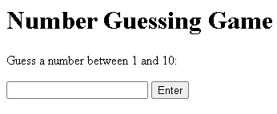***SCREENSHOT**

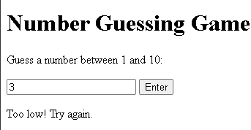

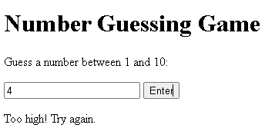

**Dictionary:**

* **Math.floor** – rounds a number down

**Syntax:** math.floor(x)

**Parameter**: x (number to round down)

This command was used to round down the generated random number

* **isNaN(value) -** Checks whether the given value is NaN (Not-a-Number).

**Syntax:** isNaN(value)

**Parameter:** value: The value to be tested. This can be any JavaScript value, such as a number, a string, or an expression.

* **JavaScript parseInt() function -** The parseInt() function is used to parse a string and convert it into an integer.

**Syntax**: parseInt(string)

**Parameter**: string: The string to be parsed into an integer.

* **textContent** The textContent property represents the text content of a node and its descendants. It can be used to set or retrieve the text content of an HTML element.

**Syntax:** output.textContent = "Invalid input: Please input a number between 1 and 10.";

**Parameter:** textContent: The text content to be set for the element.